|  |  |
| --- | --- |
| **Name** | Umar Hayyat |
| **Roll No** | 360 |

**Lab No 6**

**Introduction to function**

**Objectives:**

* How to find factorial of number by using function.
* How to find and print perfect number by using function.

**Task No 1:**

Implement the following function:

1. Function (n) which takes a number as parameter and return its factorial.

Call the above function. Initialize an integer variable from the user and pass it as parameter to the above function. Then display the factorial.

**Code:**

def factorial (a):

fact=1

for i in range(1,a+1):

fact =fact*i

return(fact)

x=int(input("Please enter a integer"))

y=factorial(x)

print(y)

**Output:**

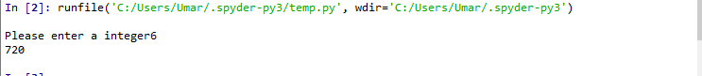

Output of Task No.1

**Task No 2:**

Modify the factorial program to call the factorial function 10 times while passing auser defined integer each time and displaying the corresponding factorial.

**Code:**

def factorial (a):

fact=1

for i in range(1,a+1):

fact=fact*i

return(fact)

for j in range (10):

x=int(input("Please enter a integer"))

y=factorial(x)

print(y)

**Output:**

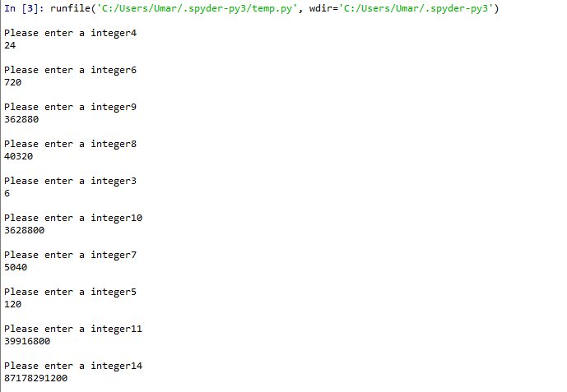Output of Task No.2

**Task No 3:**

Write a function perfect that determines whether parameter number is a perfect number. Use this function in a program that determines and prints all the perfect number between 1 and 1000. Print the factor of each perfect number to conform that the number is indeed perfect.

**Code:**

def perfect(a):

sum=0

for p in range(1,a):

if (a%p==0):

sum =sum+p

if (sum==a):

print(a,"is perfect number")

for i in range (1,a):

if a%i==0:

print(i)

for j in range(1,1001):

perfect(j)

**Output:**

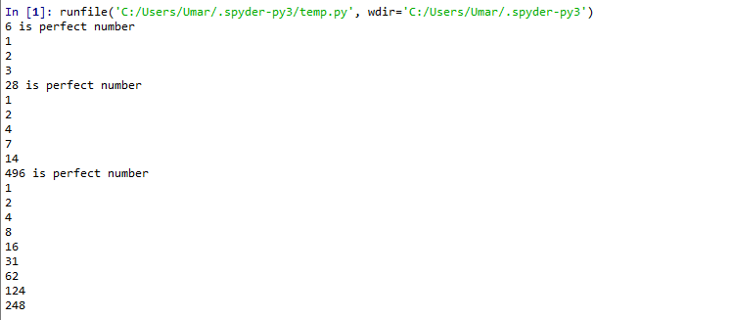

Output of Task No.3

**Conclusion:**

In this lab, I learnt how to use function to find the factorial of integer that defined by user. I also learn how to find the perfect number by using function.